Day 2: Routers and Switches Theory

Task-1 :- Draw a labelled diagram of a typical home WiFi router and a network switch, clearly marking at least 3 different ports (such as WAN, LAN, Console) and the location of status LEDs.

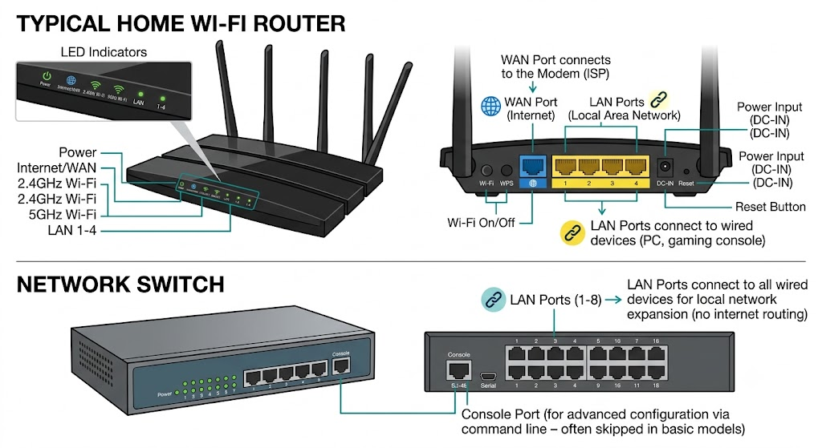

Task 2 :- List 3 key differences between routers and switches in terms of their main functions and how they handle network traffic.

Feature | Router | Switch
Main Function | Connects different networks together (like your home network to the Internet). | Connects multiple devices together within the same local network.
Addressing Used | Uses IP addresses (software addresses) to direct traffic between networks. | Uses MAC addresses (hardware addresses built into devices) to deliver data locally.
Traffic Handling | Acts like border control—inspects, filters, assigns IPs, and manages security/firewalls. | Acts like a smart dispatcher—passes data straight to the specific device without inspecting or blocking it.

Task 3 :- Take a real or virtual image of a router and a switch (from your home, lab, or Google Images), and identify the following on each: Power port, at least 2 Ethernet ports, and any LED indicators. Annotate the image or describe their position and purpose.

- Wi-Fi Router :-

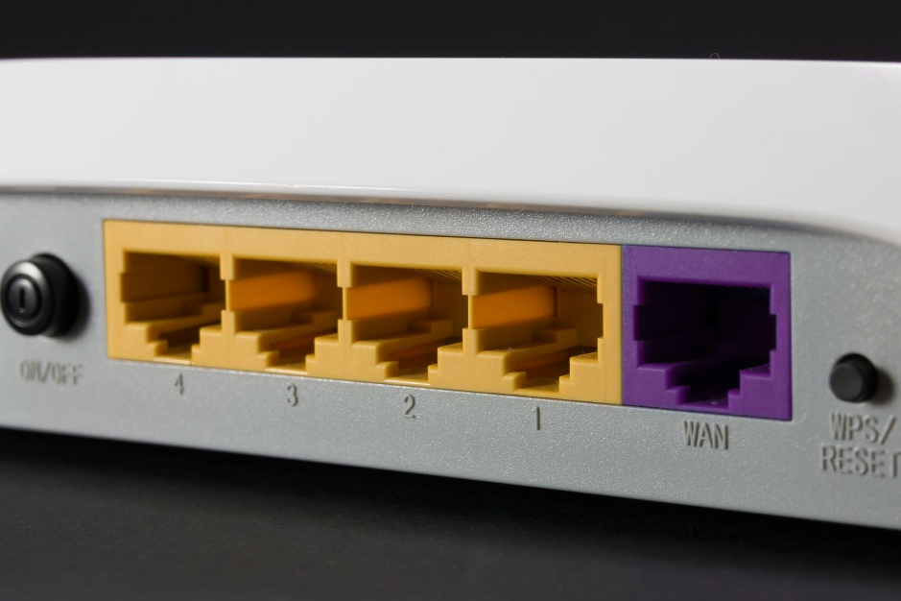

-
Power Port :
The small round hole on the far left. Connects the power adapter to turn it on.

WAN / Internet Port (Purple) :
Plug the main cable from your modem or internet line here.

Ethernet LAN Ports (Yellow) :
Four ports numbered 1 to 4. Plug your computer, TV, or gaming console here for wired internet.

LED Indicators (Top panel, not visible on back):

Power LED :
ON = device is powered up.
Internet LED :
Solid/Blinking green = internet is working.
Wi-Fi LED :
Blinking = Wi-Fi data is moving.

- Network Switch :

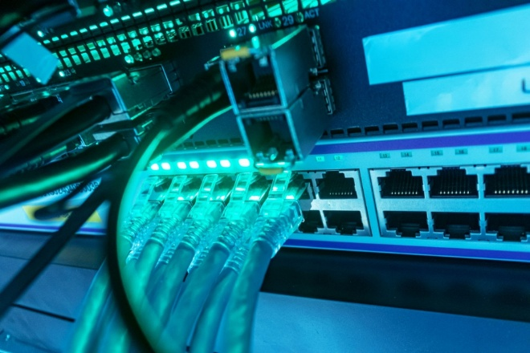

Power Port :
Located on the back or side. Plugs into the wall power outlet.

Ethernet Ports :
The long row of identical square slots. Plug cables here to connect many devices together into one local network.

LED Indicators (mini lights on port) :

Solid Light:
A device is plugged in and turned on.

Blinking Light:
Data is actively passing through that specific cable.

Task 4 : Imagine you are setting up a small gaming café network for IPL streaming and multiplayer matches. Write a short scenario explaining which device (router or switch) you would connect first to the ISP line, and how you would connect 8 gaming PCs to the network. Justify your choices.

ANS:-

Scenario :-

1st Connect the ISP line to the Router :
Plug main fiber internet cable into router's WAN(Internet) port.

2nd Connect the Router to the Switch :
Plug one Ethernet cable from a LAN port on the router into Port 1 of an 8/16 port Switch.

3rd Connect the 8 PCs to the Switch :
Plug Ethernet cables from remaining ports on switch directly inevery 8 gaming PCs.

Justify :-

Router first :
The ISP(internet service provider) gives only 1 internet connection. The router is work like "traffic manager" it translates that 1 internet line into private IP addresses for all devices protects network with a firewall, and controls traffic so IPL streams don't lag games matches. A switch cannot do any of this.

Switch handles the 8 PCs :
Most of the routers only have 4 LAN ports. Adding a GB switch gives enough physical ports for all 8 PCs while keeping network speeds fast and latency (ping) extremely low.

